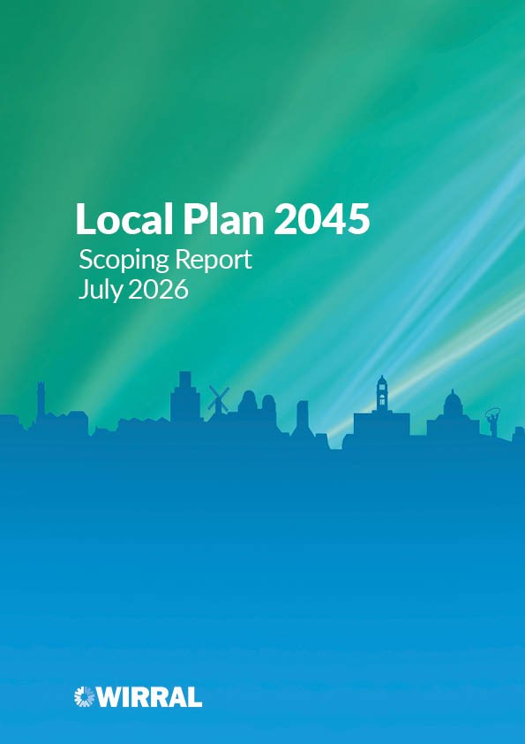

Contents
1. Introduction 2
How to get involved 2
2. The New Local Plan 4
2.1 Wirral’s adopted Local Plan 2022-2040 4
2.2 Why are we producing a new Local Plan 4
Changes to increase housing supply 4
Changes to the National Planning System 4
Wirral Local Plan 2045 progress 5
Liverpool City Region Spatial Development Strategy (SDS) 5
Strategic Environmental Assessment (SEA) 5
2.3 Local Plan Timetable 7
3. The Purpose of the Scoping Consultation 8
3.1 Community and Engagement Strategy 8
3.2 Next key steps post Gateway 1 10
4. Key considerations for the new Local Plan 11
4.1 Key priorities for Wirral 12
4.2 National Development Management Policies 13
4.3 Planning for efficient land use 13
4.4 Housing 14
4.5 Economy 15
4.6 Environment and climate change 16
4.7 Transport 17
4.8 What does this mean for Wirral 18
5. Vision 19
Appendix 1 – Consultation Bodies 21

Introduction
1.1 This consultation is the first stage in the preparation of the Council’s new Local Plan. The existing Local Plan was adopted by the Council in March 2025; however, it now requires updating to align with the Government’s new planning requirements. Wirral’s new Local Plan will be prepared under the new updated plan making system, introduced in March 2026. It will also incorporate a minerals and waste plan.
1.2 This stage follows the formal publication of the Notice to Commence an update of the Local Plan and the publication of the Local Plan Timetable, both issued on 30 June 2026. Further information can be found on the new Local Plan webpage.
1.3 The purpose of this Scoping Consultation is to provide meaningful early engagement in the plan-making process by seeking views from local residents and stakeholders as to what the plan should contain and how future engagement should be carried out.

How to get involved
1.4 This consultation will run from 15th July – 6th August 2026. You can find more information on our website. For further information or any help using the portal please contact us at the following email address – localplan@wirral.gov.uk. The Forward Planning Privacy Notice can be viewed at: Forward Planning Privacy Notice or can be requested from the email above. Comments cannot be considered without your name and postcode.
Name
Postcode

1.5 To sign up for future Local Plan and Planning Policy consultations please complete this form.

Figure 1: Map of the Wirral and surrounding areas.
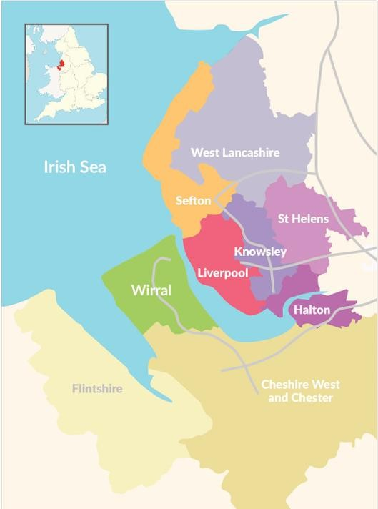

The New Local Plan

Wirral’s adopted Local Plan 2022-2040
2.1.1 Local Plans are the basis of England’s planning system, shaping how places grow and develop. They set out where new homes, jobs, infrastructure, and community facilities are located, and provide clarity for residents, businesses, and developers.
2.1.2 We have a statutory duty to prepare a Local Plan and keep it updated. Wirral’s current Local Plan was adopted in March 2025 covering a plan period of 2022-2040 with a minimum requirement for 14,400 houses over the plan period or 800 dwellings per annum calculated using the Government’s ‘standard method’ for calculating housing need based on forecasts of future growth in households in the borough. The adopted Local Plan ‘steps’ the delivery of this housing need starting from a lower-level requirement of 500 dwellings per year for the first five years and increasing to 850 dwellings per year for years 6 to 10 and then 1025 dwellings per year in the final 5 years of the plan.

Why are we producing a new Local Plan

Changes to increase housing supply
2.2.1 In December 2024, the Government announced major changes to the way that local housing needs are calculated. The change introduced a new standard method, set out in the National Planning Policy Framework which applies a percentage increase to the existing stock of housing in each Council area. Under this new approach Wirral’s local housing need has more than doubled to 1,622 dwellings per annum.
2.2.2 At the same time, further changes to Government Planning Policy in the National Planning Policy Framework (NPPF) also issued in December 2024 required that Councils with existing Local Plans in preparation which provided for less than 80% of this new house housing need figure (which includes Wirral) would have to start work on a new Local Plan as soon as the new plan making system the Government were introducing came into effect (paragraph 236 refers).

Changes to the National Planning System
2.2.3 This new Local Plan system was established under the Levelling Up and Regeneration Act 2023 and has fundamentally changed the process for preparing Local Plans to speed it up and to deliver more succinct documents that are easier for people to use.
2.2.4 The new system came into effect on 25th March 2026 with the commencement of regulations setting out how a Local Plan should be prepared. The introduction of these Regulations is the trigger that means that the Council, identified as a ‘Backstop 1 Authority’ must begin preparing a new style Local Plan.
2.2.5 Transitional provisions in the 2026 Regulations set specific statutory deadlines for authorities affected by paragraph 236 of the 2024 NPPF. These authorities are called “Backstop 1 Authorities” and must begin preparing their plans almost immediately.

Wirral Local Plan 2045 progress
2.2.6 The Council published a Notice of Intent to Commence (Regulation 19) and the Local Plan Timetable (Regulation 4) on 30 June 2026. The Council is required to undertake this Scoping Consultation (Regulation 20), prior to passing through a Gateway 1 Self-Assessment by 31 October 2026, which marks the start of the formal plan making process.

Liverpool City Region Spatial Development Strategy (SDS)
2.2.7 A key strategic factor for the Council is the Liverpool City Region Combined Authority (LCR) Spatial Development Strategy (SDS), which is being progressed alongside the new plan making system and will provide an overarching spatial framework for the city region, including setting out the scale and distribution of housing and employment growth. Our Local Plan will need to be in general conformity with the SDS. Once adopted, the SDS will form part of development plan for Wirral and carry significant weight in decision making. Wirral continues to be actively engaged in the preparation of the SDS.

Strategic Environmental Assessment (SEA)
2.2.8 Proposed plans, policies and strategies must be subject to a robust, high-level process to evaluate their potential environmental impact prior to adoption. This is typically undertaken through an SEA. As part of the new Local Plans system, the Government is intending to replace SEA and Environmental Impact Assessments (EIAs) with Environmental Outcomes Reports (EORs). However, at the current time these requirements have not been formalised through regulations and, as such, the 2004 SEA Regulations continue to apply.
2.2.9 In addition, the requirement for a broader Sustainability Appraisal (SA), incorporating social, economic and environmental considerations, as undertaken for the current Local Plan, has been removed. As a result, and during this transition period, the Council is proposing to undertake an Integrated Impact Assessment to inform the Local Plan. This incorporates the functions of an SEA, Equalities Impact Assessment (EQiA), and an
assessment of community safety. A separate Habitats Regulations Assessment (HRA) which assesses whether the Local Plan will have a significant adverse effect on protected ecological sites will also be undertaken.

Local Plan Timetable
2.3.1 Our new timetable has been prepared in line with the new plan-making expectations and replaces the previous Local Development Scheme. The timetable is available on our website here. This will be updated throughout the plan making process.
Figure 3: Local Plan timetable
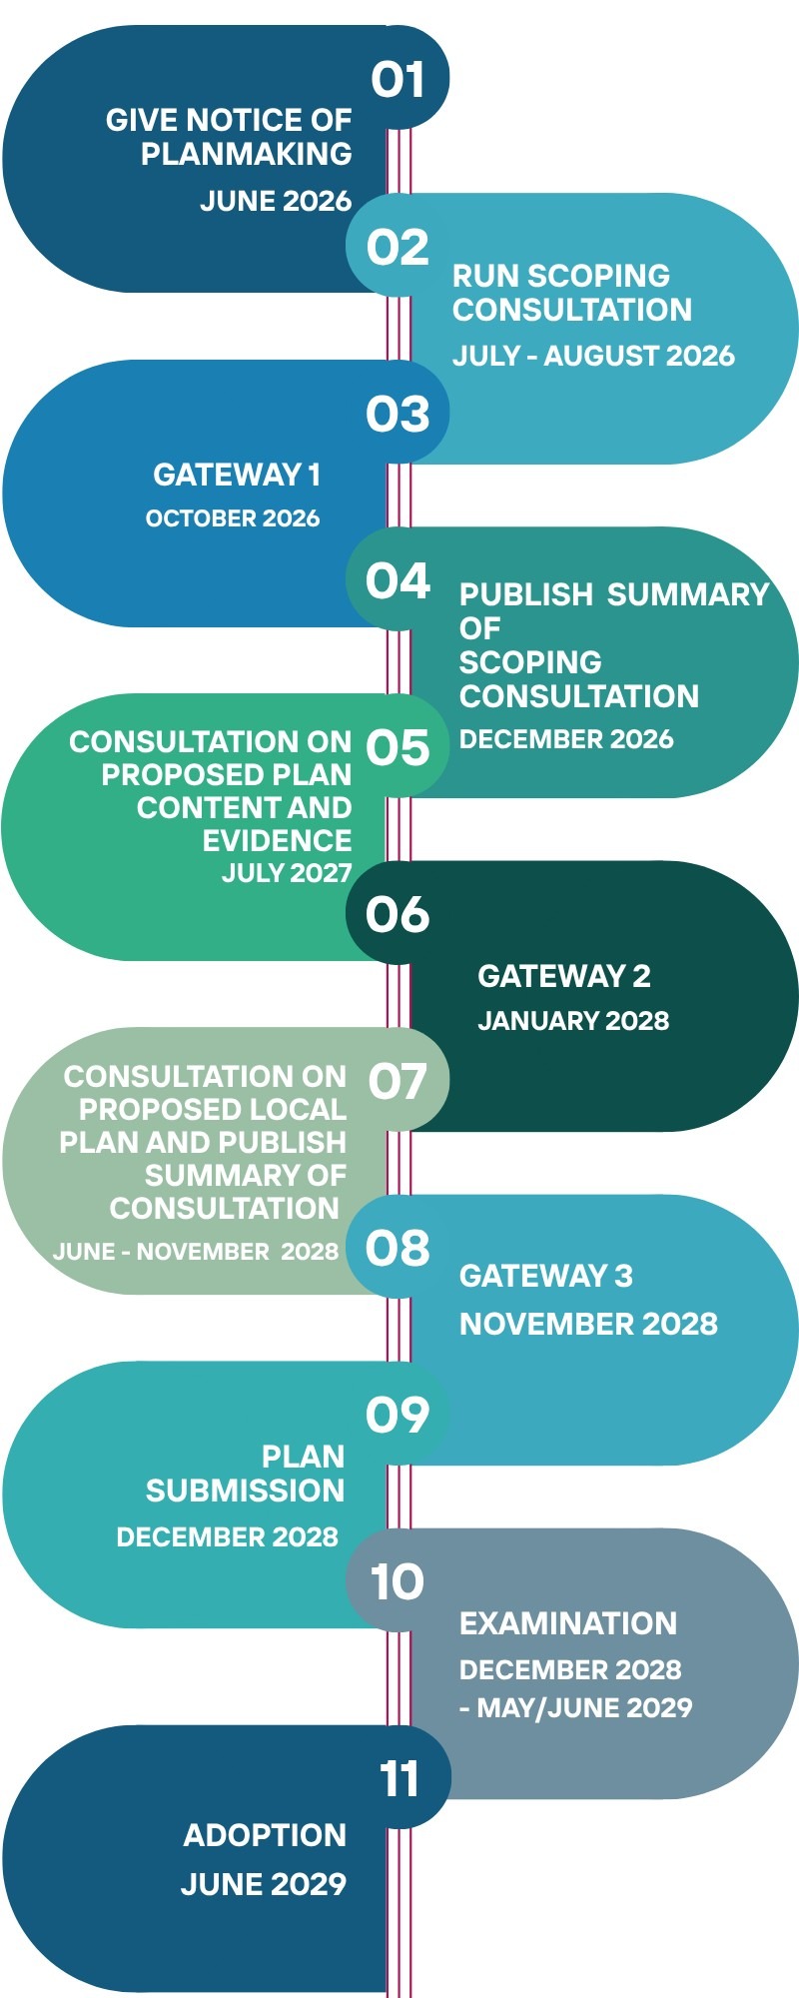

The Purpose of the Scoping Consultation
3.1 The new plan-making system details the processes that must be followed to ensure that the plan is considered sound.
3.2 Before the Local Plan can pass through the first Gateway of the new planmaking system (Gateway 1), the Council must carry out this scoping consultation. This early stage seeks views on what the new Plan should cover and how we, as a Council, should engage with communities and stakeholders as the Plan progresses.
3.3 As part of this scoping consultation, we are notifying and inviting views from individuals and organisations, as required by the Regulations. This is similar to the way we have previously consulted for the purposes of plan-making. The ‘relevant’ and ‘general’ consultation bodies as referenced in the Regulations are set out at the end of this document in Appendix 1.
3.4 This consultation will help ensure that we develop a clear understanding of the likely scope of our new Local Plan, including:
- identifying the main themes and locally specific issues you think our Plan should address; and
- how you want us to engage with you in the plan-making process
3.5 At the end of the Scoping Document consultation, we will be publishing the Scoping Consultation Summary which will include:
- the main issues raised in the responses received; and
- how we will have regard to those responses at the point of publication.

Community and Engagement Strategy
3.1.1 We have previously engaged with the local community and other important stakeholders in accordance with the Council’s Statement of Community Involvement (SCI). The SCI sets out how and when the community will be involved in the preparation of the Local Plan and other planning documents and how they will be consulted on planning applications.
3.1.2 The 2026 Regulations do not make provision for an SCI in relation to ‘new’ Local Plans prepared under the LURA. Instead, requirements for public and stakeholder engagement in relation to the Local Plan are to be met through an engagement strategy, supported by statutory consultation requirements set out in the Regulations and relevant national guidance, including guidance on neighbour notifications. As we consider how we are going to consult on our new Local Plan, we want your views on how we have consulted in the past, what worked well and what may be improved. The Regulations require that

the new Local Plan must be published on the Council’s website in a searchable electronic format, but we will also need to offer documents in alternative formats and maintain non-digital options for those with limited online access.
Table 1: Proposed engagement options
Plan-Making Stage | Proposed Comms  Method | Target Audience
All Stages  - Proposed Content and Evidence Base Consultation  - Draft Local Plan Consultation | Mail out to those identified on postal and email consultation database only | borough wide including residents, businesses, hard to reach groups and other stakeholders
Press Releases
Social Media:
Facebook, Instagram, X,
LinkedIn
 | Wirral View – online magazine for residents
 | Hard copies of documents available in principal office and libraries
Online publication of documents on our website in both PDF and
HTML format*
 | Walk in exhibitions, webbased interactive engagement portals, such as placemaker. Targeted consultation may also be undertaken with “hard-to-reach” groups including those with special needs, specific interests or within specific geographical areas**
*Documents will be made available in an easy read format and can be requested in alternative languages, other accessibility requests will be responded to accordingly. **all venues will accessible.

QUESTION 1 | Are there any other methods of communication or engagement that you would consider more effective and that we should consider that we haven’t already included?  Existing proposals seem very comprehensive

QUESTION 2 | Do you have any views on how we can best ensure that all communities and demographics are able to meaningfully participate in the Local Plan process?  Existing proposals should achieve this except for one important omission:  Please add Wirral Green Space Alliance to list of consultees, as their extensive network and input was greatly appreciated by the LPA during the development of the current plan. WGSA represent over thirty groups on the Wirral with extensive memberships.

Next key steps post Gateway 1

Consultation on proposed Local Plan Content and Evidence - 2027
3.2.1 The following information will be consulted on;
- The draft Plan vision and any proposed aims and objectives
- The proposed spatial strategy, including the approach to minerals and waste policies
- A summary of the evidence we intend to gather and details of any evidence we have already gathered
- Other supporting information which may include initial draft policies

Gateway 2 (January 2028)
3.2.2 The second gateway takes place after the first consultation on the draft Local Plan. It involves getting feedback and advice from a planning inspector on progress, including how well the plan is meeting the requirements for Gateway 3.

Consultation on the proposed Local Plan – 2028
3.2.3 This consultation will provide the opportunity to comment on the full draft Local Plan plus the Polices Map, supporting evidence and Strategic Environmental Assessment Environmental Report.

Gateway 3 (November 2028)
3.2.4 The third gateway takes place after consultation on the proposed Local Plan. It involves a final check by a planning inspector to confirm that all legal requirements are met before the plan can be submitted for examination.

Examination 2028-2029
3.2.5 The Local Plan is submitted to the Planning Inspectorate for examination which will consider whether the Local Plan is sound – meaning it meets the test of soundness set out in national planning policy. Those who have made representations on the plan during its preparation will have the right to present their views to the inspector.
3.2.6 Following the examination if the inspector finds that the plan is sound or could be made sound subject to modifications the Council will be expected to adopt the Local Plan and make it available.

Key considerations for the new Local Plan
Background
4.1 Wirral is a vibrant and prosperous borough with many positive qualities. Around 76.8% of the working-age population is economically active, supported by a diverse local economy and a broad range of employment opportunities. Approximately 145,000 residents are in employment, and the borough continues to benefit from a dynamic and evolving business base, contributing to its role within the Liverpool City Region economy.
4.2 Health outcomes in Wirral are more mixed and reflect significant inequalities across the borough. Life expectancy is below the national average, at around 78 years for men and 82 years for women, with pronounced disparities between communities, particularly between the east and west of the borough.
4.3 The borough has an ageing population, with a median age of around 44, and an increasing proportion of older residents. This creates a range of shared challenges and opportunities, including for housing, health and social care services, transport, and the role and design of town centres.
4.4 Levels of health and wellbeing are closely linked to patterns of deprivation. While Wirral benefits from many strong and resilient communities, it is among the more deprived local authority areas in England. The borough is ranked 28th most deprived nationally, and around 23% of neighbourhoods are classified as highly deprived, significantly above the national average.
4.5 International recognition of Wirral’s wildlife primarily relates to the extensive peninsula coast and estuarine wildlife with intertidal mudflats and sandflats, together with saltmarsh. There is an overlapping network of designations including International Special Areas of Conservation (SAC), Special Protection Areas (SPA), Ramsar Convention Wetlands and national Sites of
Special Scientific Interest (SSSI). In addition, the wide range of habitats in the borough include, wetlands and watercourses, woodland and trees, grasslands

and heathlands as well as agricultural grasslands. Irreplaceable habitats and protected species are subject to clear legal and policy protection.
4.6 The Council’s statutory duties in respect of nature conservation and improvement are linked in with the wider city region and a Local Nature Recovery Strategy has recently been adopted, also founded in work with statutory bodies such as Natural England, and voluntary groups. These natural assets play an important role in supporting residents’ physical and mental wellbeing and contribute significantly to the borough’s sense of place.
4.7 Wirral has a rich and varied built heritage, reflecting its historic towns, villages, and coastal setting. This includes a significant number of Listed Buildings, Schedule Monuments, Historic Parks or Gardens and designated
Conservation Areas. These include places such as Port Sunlight (a nationally important model village), Hamilton Square and Birkenhead Park. Together, these assets illustrate Wirral’s development, and they are an important part of its identity, townscape quality, and cultural value.
4.8 Wirral environmental resources and built heritage are an important part of what makes Wirral distinctive. However, they also present both opportunities and constraints when considering how the borough should grow and develop in the future. Balancing the need for regeneration, housing delivery, and economic development with the protection of these assets will be critical.
4.9 At the same time as responding to wider economic challenges, it is important to ensure that development remains viable and deliverable so that investment can come forward to support sustainable growth and improved outcomes for local communities.

Key priorities for Wirral
4.1.1 At this early stage, it is important for us to understand what matters most to you about the future of Wirral. People’s priorities will differ, and your feedback will help shape a Local Plan that reflects the needs, aspirations and character of our borough.
4.1.2 The draft NPPF sets out key topic areas that all Local Plans have to address. These include:
- Sustainability • Minerals and Waste
- Climate Change • Effective use of Land
- Housing • Green Belt
- Employment and Retail • Design
- Communications and • Transport
Infrastructure
- Health, Pollution and Safety • Natural Environment
- Flood Risk • Historic Environment

National Development Management Policies
4.2.1 One of the most significant changes in the new framework is the introduction of National Development Management Policies (NDMPs).
4.2.2 NDMPs are intended to provide consistent national policies on certain planning matters, such as design, heritage and site sustainability. Their purpose is to reduce repetition across Local Plans and ensure that these issues are dealt with in a consistent way across the country.
4.2.3 As many topics previously covered by Local Plans will now be addressed through NDMPs, it will not be necessary to repeat these policies in our new Local Plan. The Local Plan should only add local detail where national policy specifically says this is required. We cannot include local policies that try to do something different to the NDMPs such as imposing stricter targets on developers.
4.2.4 As the existing Wirral Local Plan was adopted relatively recently in March 2025, we will go through a process of considering which of the detailed policies in the existing Local Plan can be carried forward into the new Local Plan, potentially in modified form to take account of the introduction of NDMPs. However, it is likely that the new Plan will be different from the existing adopted Wirral Local Plan; it will be shorter and more streamlined, placing greater emphasis on issues, challenges and opportunities that are specific to Wirral.

Planning for efficient land use
4.3.1 In order to meet the requirements of the new NPFF, we need to make the most efficient use of land. The Local Plan will need to explore new and innovative ways of using the land that is available, whilst protecting our environmental and historic assets. The new plan will create series of opportunities and challenges and as a Council we need to:
- manage competing demands for land across the borough, balancing the need for homes, jobs, infrastructure and environmental protection
- ensure that infrastructure keeps pace with growth, so communities have the services and facilities they need
- ensure that all development meets high standards of design and quality, so it is fit for the future and meets the needs of residents and employees both now and over the long term
- identify opportunities for mixed-use development so that homes, jobs and community facilities are located close together, making it easier for residents to access everyday services.
QUESTION 3 | Do you think there are any other challenges or opportunities we should be aware of in relation to efficient use of land?  Encourage use of solar panels on industrial buildings to prevent land being lost to solar farms.  Prevent loss of land through carbon capture pipelines and pumping stations.  Maximise the opportunities presented by densification within existing townships.  Build over town carparks  Fully exploit Wirral Waters land

Housing
4.4.1 A key driver for the new plan is the need for more homes. The existing Local Plan sets out a minimum requirement of 14,400 homes over the Plan period, under the former standard method requirement of 800 dpa, this has increased to 1,622 dpa under the revised standard method introduced in December 2024 in National Planning Policy Guidance. This means that we must identify additional land beyond current allocations to help avoid unplanned growth. However, challenges relating to increased pressure on existing infrastructure and services will need to be addressed and planned for thoroughly. It is important to note that sites allocated in the current Wirral Local Plan 20222040 which haven’t been developed will remain allocated for development to meet the housing numbers set out in that plan and will continue to count towards our housing requirement.
4.4.2 The new Local Plan gives Wirral the chance to address wider housing issues, as a result we need to:
- explore opportunities to deliver sufficient levels of affordable housing, ensuring a range of housing options are available to meet the needs of all residents
- ensure that a range of suitable homes are provided for older people, residents with disabilities as well as those with other specialist needs
- deliver housing designed to be accessible and adaptable to meet changing needs over time
- understand and plan for the land and housing needs of Gypsy and Traveller communities, ensuring their accommodation needs are appropriately met within our District

QUESTION 4 | What do you think we need to consider in planning for more homes?  The use of the 2024 NPPF standard method results in an illogical housing requirement which bears no relationship to real need or infrastructural capacity. These numbers should be strongly challenged.  The very successful approach of brownfield only in the current plan should be stretched to the very limit to provide the required sites for new homes and to preserve the Green Belt. Many brownfield sites were identified in the development of the current plan, but were not included in the final housing trajectory. Maximise the opportunities presented by densification within existing townships. Further encouragement of change of use from commercial to residential.  Ensure infrastructure is capable of supporting any proposed development (transport, health, retail, schools, sewage, water supply, proximal access to recreational spaces)  The current Local Plan makes provision to address GP provision for larger new developments but the critical shortage in secondary hospital care and A&E on Wirral must be recognised. Any increased demand on these overstretched services by the building of new homes should only approved following a full assessment of the future capability and capacity of the NHS Cheshire and Merseyside Integrated Care Board to meet the additional needs.

QUESTION 5 | Are there any places that you think could benefit from new homes? You might want to consider places with good transport links, access to jobs, or where new homes could help regenerate underused or neglected land or help support underutilised local services.  Focus should continue on brownfield sites in North and East of Wirral. Wirral Waters still has huge development potential. Build above town centre carparks.

Economy
4.5.1 Ensuring sufficient employment land is critical to support Wirral’s ongoing economic success. Wirral has a diverse business base with a strong presence in some of the City Region’s identified growth sectors – including advanced manufacturing, maritime, digital & creative, health and life sciences and the visitor economy. As a Council we need to ensure that employment land that is well located and accessible, helping residents to live and work within Wirral and supporting a strong local economy.
4.5.2 A current challenge for Wirral is the availability of employment land. This means that our new Local Plan will need to identify further employment sites for development. National policy states that planning policies should facilitate development to meet the needs of a modern economy, including identifying suitable locations for uses such as laboratories, gigafactories, data centres, digital infrastructure, freight and logistics
4.5.3 As a Council we need to:
- provide sufficient employment land to meet our employment needs
- improve existing employment sites where they are outdated or no longer meeting modern standards
- Provide a range of employment and mixed-use sites to meet needs, attracting inward investment, provide work opportunities for our residents and foster an environment where existing businesses and new, innovative start-ups can prosper - whilst supporting a thriving and diverse rural and visitor economy.

QUESTION 6 | Do you think there are any other challenges and opportunities we should be aware of in relation to economic issues?  Need to build skill base, particularly for the younger generation, to prepare them for the future opportunities. Encourage development/expansion of technical colleges.

QUESTION 7 | Where do you think new jobs should be located in Wirral?  Employment opportunities should be pursued everywhere wherever an opportunity arises but priority should be given to the North and East side of Wirral where unemployment is highest but the opportunity for job creation is the highest.

QUESTION 8 | What types of employment should we be seeking to target?  All types of employment should be championed whether manufacturing or service.  Apprenticeship schemes should be strongly encouraged, also retraining opportunities for mid-career people made redundant as AI impacts traditional businesses.

Environment and climate change
4.6.1 The borough is home to a wealth of natural heritage at all scales, reflected in the extensive coastline, geological features, parks, and woodland down to the scale of individual veteran trees. The mosaic of countryside, woodland, grassland, trees, rivers and streams and both urban and rural spaces are important culturally and for good health, whilst being valued for their landscapes, enjoyment, recreation, education and the plants and animals they support. These spaces include public elements, such as allotments, cemeteries, ponds, streams, and roadside verges, and private elements, such as individual gardens or meadows. Many are protected under law or national policy but not all. This Plan protects all locally important designated sites and seeks biodiversity net gain to address the Environment and Climate emergency.

4.6.2 The Council has declared a Climate Emergency, which means we must carefully consider the environmental impacts of any new development in Wirral. The Council committed to reaching a net zero carbon target locally by 2041 on 15th July 2019, and in addition to its own policy agenda on climate change, is a member of the Cool Wirral Partnership, working with a range of organisations in Wirral. Our new Local Plan needs to ensure that all development helps reduce carbon emissions, minimises harm to the environment, and incorporates measures to mitigate and adapt to the impacts of climate change.

4.6.3 As the Council is both a minerals planning authority and a waste planning authority, the new Wirral Local Plan will include waste policies in some form, as the plan period for the current Joint Waste Local Plan for Merseyside and Halton runs to 2027

4.6.4 In order to help mitigate against climate change the plan will need to:

- prioritise development in locations well served by public transport to support more sustainable travel choices, and ensure new development is designed to enable and encourage walking and cycling both within sites and to surrounding areas
- reduce carbon emissions through sustainable construction methods and by improving the long-term energy performance of buildings
- Support sustainable approaches to the location, design, construction, operation and impact of new development and infrastructure, to help secure the extremely rapid reduction in local emissions needed to stay

compatible with the latest international climate agreement and nationally legally binding targets to reach net zero carbon
- Make responsible use of land and natural resources to mitigate and adapt to climate change and enhance natural carbon stores and promote the transition to a low carbon borough and circular economy, reusing and recycling waste and minerals

QUESTION 9 | How can planning and development help support climate action and green energy in Wirral?  Encouragement of solar power on all new developments.  Better use of SUDS for surface water on all developments and encourage rainwater harvesting schemes.  Encourage reuse of existing buildings rather than rebuild.  Renewed focus on Wirral Tree Strategy.  Better enforcement of landscape schemes and replacement trees forming part of planning and tree-work approvals.  Enforcement of provision of electric vehicle charging points in all new developments.  Follow recommendations of protecting environment provided by Wirral Wildlife.

Transport

4.7.1 Wirral is well connected – the majority of the borough has good rail connections: a frequent and high quality Wirral Line commuter service runs to Liverpool City Centre via the Mersey Railway network which connects underground to the national rail network and the sub regional Northern Line; services also run to Ellesmere Port and Chester; and to Wales via a service from Wrexham to Bidston. A good network of bus routes is also in place whilst the on and off-road cycle routes serve the borough well along with the public rights of way network. Liverpool John Lennon Airport is within a thirty-minute drive and Manchester airport is within an hour of the borough by road.
4.7.2 By road, Wirral benefits from a well-connected highway network, including the M53 motorway running north–south through the peninsula, linking directly to the M56 and wider national motorway network. Key A roads such as the A41, A540, A552 and A553 provide strategic routes across the borough and connections to Liverpool via the Kingsway (Wallasey) and Queensway (Birkenhead) Mersey Tunnels. Together, these routes offer convenient access to surrounding towns, cities and regions across the Liverpool City Region, Cheshire and North Wales.
4.7.3 Wirral has strong maritime transport links, with the Port of Birkenhead serving as a major regional freight and passenger hub, with ferry services linking Merseyside to Belfast and supporting significant trade and logistics activity. These maritime connections, combined with road and rail links to the port, play an important role in the Wirral’s economy and accessibility.
4.7.4 We need to:
- Work closely with Liverpool City Region Combined Authority to help deliver the goals, principles, policies and priorities set out in the Adopted Local
Transport Plan (April 2026),
- Recognise the Government’s preference for locating development close to railway stations, and prioritise sites with the strongest potential for good walking, cycling and public transport connections
- coordinate planned development with the provision of new and improved transport infrastructure and services
- Ensuring that high quality, sustainable connections and access to planned development, with priority given to walking, cycling and public transport within the design, so growth is supported by sustainable and accessible travel options
- manage the impact of additional vehicle trips generated by new development, including their individual and cumulative effects on congestion, road safety and air quality, particularly in relation to reducing carbon emissions from transport in line with national requirements and our local climate commitments
- plan parking provision carefully so it supports development needs while making efficient use of land and encouraging sustainable travel choices
QUESTION  10 | Do you think there are any other challenges and opportunities we should be aware of in relation to transport issues?  The proposed upgrading of the Wrexham-Liverpool railway to provide four direct trains per hour by 2035 through Heswall Hills Station could offer major opportunities for Heswall which needs to be considered in the new Plan 2045. To maximise the benefit there would need to be much better parking provision.There will also be implications for Upton.  Heswall is a major pinch point on the A540 with no opportunity for bypassing and this should be factored into future infrastructure assessment of major development proposals.  Wirral needs a much better integrated network of cycle routes, current is too disjointed.

What does this mean for Wirral
4.8.1 We have to carefully balance the demand for homes, jobs and infrastructure with the need to protect and enhance our important environmental and historic assets. This means making difficult choices about where development should go, ensuring it delivers the things communities need, while safeguarding what makes Wirral unique. Our Local Plan is about striking that balance and achieving the best outcomes for now and into the future.

Please choose three of the most important issues out of the topics below that you think would be critical in the production of the Local Plan
All of these topics are essential components of a sound Local Plan and we see no merit in trying to prioritise them, as they all need to be addressed. Ranking them would be counterproductive as it might be considered that some are more important than others, and the lower ranked ones could be given less attention and resources.
Table 3: Priority Ranking List
Topic areas
Improve employment opportunities and support the economic regeneration of the borough
Meeting the housing requirement set out in the Plan. Providing the right homes in the correct location, including affordable and specialist housing
Provide a range of sustainable transport options and making sure active travel is a priority
Protecting our landscape and natural environment, improving biodiversity, improving air quality and reducing the risk of flooding.
Protect our historic and cultural environment
Ensure that residents have good access to open spaces, playing pitches and that children’s play spaces.
Ensuring high quality and sustainable design

Vision
5.1 To help develop a Local Plan vision that genuinely reflects Wirral, we are considering both what our Local Plan should deliver and the characteristics that make the borough distinctive. Under the new Local Plan system, the vision should be supported by no more than ten measurable outcomes which will form the basis for monitoring plan progress.
5.2 We will take into account the features that define Wirral, including:
- our rich and varied heritage, including historic settlements, conservation areas, and maritime connections across the Mersey
- the distinct character and identity of our towns, from Birkenhead and Wallasey to Heswall, West Kirby and beyond
- our distinct identity as a peninsula, shaped by our coastal setting, the Dee and Mersey Estuaries, and the influence of nationally and internationally important environmental designations
- our strategic location within the Liverpool City Region, our economic role, and strong connections to Liverpool, Cheshire, North Wales and the wider Northwest
- The things about Wirral which feel special and important to people who live here.
5.3 In developing the vision, we will consider how our Plan can address the priorities that emerge from the challenges and opportunities facing the borough, including:
- addressing climate change by supporting development that reduces carbon emissions, protects natural assets and helps communities adapt to risks such as flooding and coastal change, in line with our climate commitments
- meeting housing needs by planning for a sufficient supply of appropriate, well-located homes that meet the needs of all of the community
- supporting a strong and diverse local economy by enabling business growth, supporting town centres creating jobs, and building a resilient, future-ready economy
- promoting sustainable and safe development by ensuring growth is focused in accessible locations, well connected by public transport, walking and cycling networks, and designed to be inclusive and safe for all
- supporting thriving communities that are healthy, inclusive and resilient, promoting wellbeing, reducing inequalities, and enhancing quality of life across the borough
- protecting and enhancing the natural environment by safeguarding important habitats such as the Dee Estuary SPA, improving biodiversity, maintaining high standards of air and water quality, and ensuring development works in harmony with nature
  - Together, these considerations will help shape a Local Plan vision that reflects Wirral’s priorities, recognises what makes the borough unique, and guides future development but provides enough flexibility so Wirral can grasp opportunities to develop to meets the changing needs of its communities.
  - We want your feedback on whether these issues reflect what matters most to you and whether there are other aspects of Wirral’s future that should be reflected in the vision.

QUESTION  11 | Do you think these are the right issues to be considered for our Vision?
QUESTION  12 | Are there any other issues that you think we should be including?  No mention of importance of good design in Vision, although it is singled out as an important topic in the last bullet point in 4.8.1.  Add Wirral Green Space Alliance to list of formal consultees, as their extensive network and input was greatly appreciated by the LPA in the development of the current plan  Retain a brownfield only Local Plan.  The content and intent of the current separate Supplementary Planning Documents will need to be integrated into the body of the future Local Plan text in a future where most decisions will be made by planning officers without recourse to Planning Committees. Great care will be needed to ensure there will be no ambiguity in the way National Development Management Policies are interpreted by case officers in the local context.

Appendix 1 – Consultation Bodies
Mersey Forest  Cheshire Wildlife Trust  Wirral Wildlife  Civil Aviation Authority  Office of Rail Regulation  Liverpool Airport  Hawarden Airport  Marine Management Organisation  MEAS  Merseytravel  Natural England  Network Rail  Cheshire Highways  United Utilities  Welsh Water  Wirral Highways  Liverpool Highways  Historic England  National Highways  Homes England  Environment Agency  NHS Cheshire and  Merseyside  Wirral Community NHS Trust  Devonshire Park  Neighbourhood Forum | Hoylake  Neighbourhood Forum  Canal and River Trust  Coal Authority  Forestry Commission  Merseyside Police and  Crime Commissioner  Merseyside Fire &  Rescue Service  Sport England  Health and Safety  Executive  National Grid  Cadent Gas  SPEN (Scottish Power)  Openreach  Vodaphone and O2  (Telefonica)  Three  Virgin Media  EE  Natural Resources  Wales  Crown Estates  Active Travel England  Office for Nuclear  Regulation  Lead Local Flood Authority  Sefton Council | Liverpool City Council  Liverpool City Region Combined Authority  Liverpool City Region  Combined Authority  St Helens Council  Knowsley Council  Halton Council  Flintshire Council  West Lancs Council  Cheshire West &  Chester (CWAC) Council



https://www.wirral.gov.uk/planning-and-building/statement-community-involvement
https://www.nomisweb.co.uk/reports/lmp/lad/1778385138/report.aspx
Labour Market Profile - Nomis - Official Census and Labour Market Statistics
https://www.gov.uk/government/statistics/english-indices-of-deprivation-2025/english-indices-ofdeprivation-2025-statistical-release
The Cool Wirral Climate Strategy 2025–2030 - https://www.wirralhealthwellbeingknowledgehub.co.uk/media/xuhb11sj/cool-wirral-3-climate-actionstrategy_web-copy-ac.pdf

