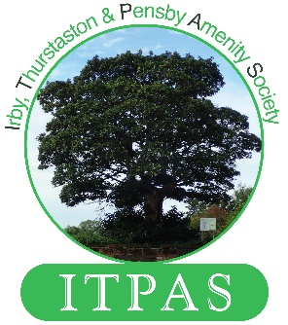
Irby Village
Tidy-Up

Irby Thurstaston & Pensby Amenity Society

This is your opportunity to HELP keep the village
looking at its best

Just an hour or two of your time
will make a great difference.

It’s also great exercise !!!

Meet at Irby Library


23rd August 2026 Sunday @ 10.00AM

Village tidying, weeding and maintenance of the
Pavements, Flower beds, Planters and Library area.
We have some Tools, Gloves, Safety jackets etc.
but we welcome you bringing
your own hand tools, spades, brushes etc.


For more information please go to

www.itpas.org/events
or contact
events@itpas.org
ITPAS is the registered charity # 1150756 Est 1974

